ABHISHEK SHARMA

500067644

R171218005

**CLOUD COMPUTING**

**Introduction:**

* **Cloud Simulator**:Cloud simulatoris software that allows you to simulate the physical and logical structure of data centers in the cloud, which contains thousands of physical machines and hundreds of thousands of virtual machines in an ordinary computer

**Cloud Simulation tools:**

* CloudSim
* CloudAnalyst
* GreenCloud
* iCanCloud
* GroudSim
* **Cloud Provider:** A cloud service provider is a third-party company offering a cloud-based platform, infrastructure, application, or storage services. companies typically have to pay only for the amount of cloud services they use, as business demands require.

**Types of Cloud Providers:**

1. **Open Source Cloud Providers: -**

* Open Stack
* CloudStack
* Eucalyptus

1. **Commercial Cloud Providers: -**

* AWS
* Microsoft Azure
* Google Cloud

**Simulation tools**

**1) Cloud Sim: -**

* Models Cloud Computing Environments , Data Centres ,VM ,application
* Written in Java
* Allows to Examine Application Services
* Allows to examine application Services
* Allows Dynamic addition/removal of Resources
* Developed at clouds Lab at University of Melbourne

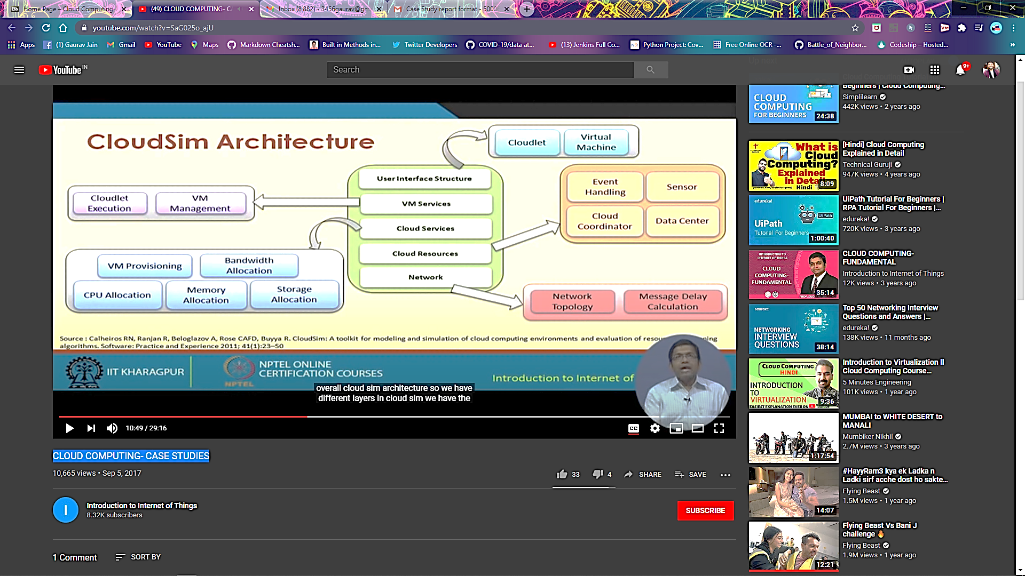

**Advantages of CloudSim:**

* Time Effectivness
* Flexibility and Applicability

**Architecture of CloudSim:**

1) Topmost Layer (Machine and application Specification)

* Users,Physical Machines,Virtual Machines,Application and Services,Scheduling Policies

2) Middle Layer

* Provides Cloud Environment
* Enables Modeling and Simulation

3) Bottom Layer

* Event Scheduling
* Entity Creation
* Interaction between Components
* Clock Management

**2) CloudAnalyst :**

* Simulation tool designed based on CloudSim Provides GUI
* Supports geographically distributed large-scale-cloud Applications
* Study Behaviour of such Applications Under Various deployment Configurations

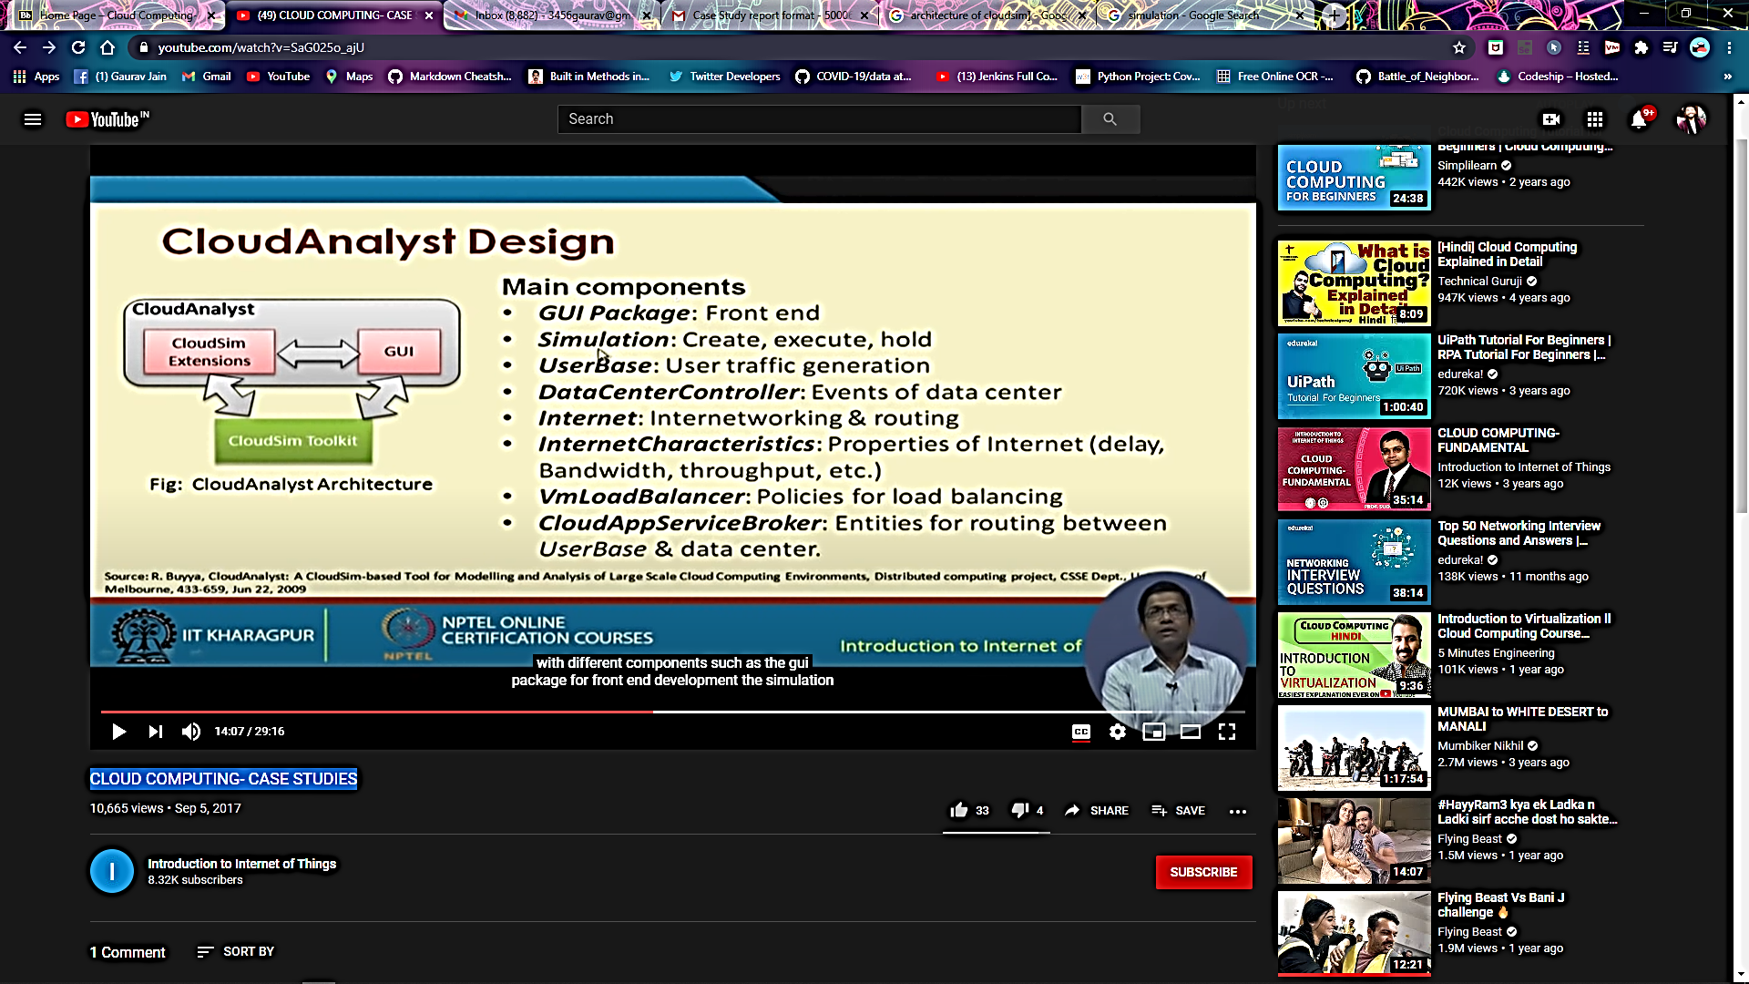

**Features of CloudAnalyst**

* Easy to use
* High level Configuration
* Graphical Output
* Easy to Extend

**Main Components of CloudAnalyst :**

* GUI
* Simulations
* Userbase
* DataCenter Controller
* VM Load Balancer
* cloudApp Service Broker

**3) Green Cloud:**

**Why:**

* The computing capacity has increased the cost and operational expenses of dataCenters
* Energy Consumption by Data Centers is the Major factor driving Operational Expense

**What:**

* Operational Cost is the Energy utilized by Computing and Communication units within a data Center

**How:**

* Green Cloud monitors the energy consumption of switches ,servers etc
* Developed as an Extension of a packet-level simulator NS2

**Features:**

* User Friendly GUI
* Open Source
* Monitors Energy Consumption
* Supports Simulation of Cloud Network Components

1. **Open Stack**

* Collection of open Source Technologies
* Managed by open stack Foundation
* Supports Vastly scalable Cloud System
* Considered as Iaas
* Ease of use
* Developed software applications can be used by end user

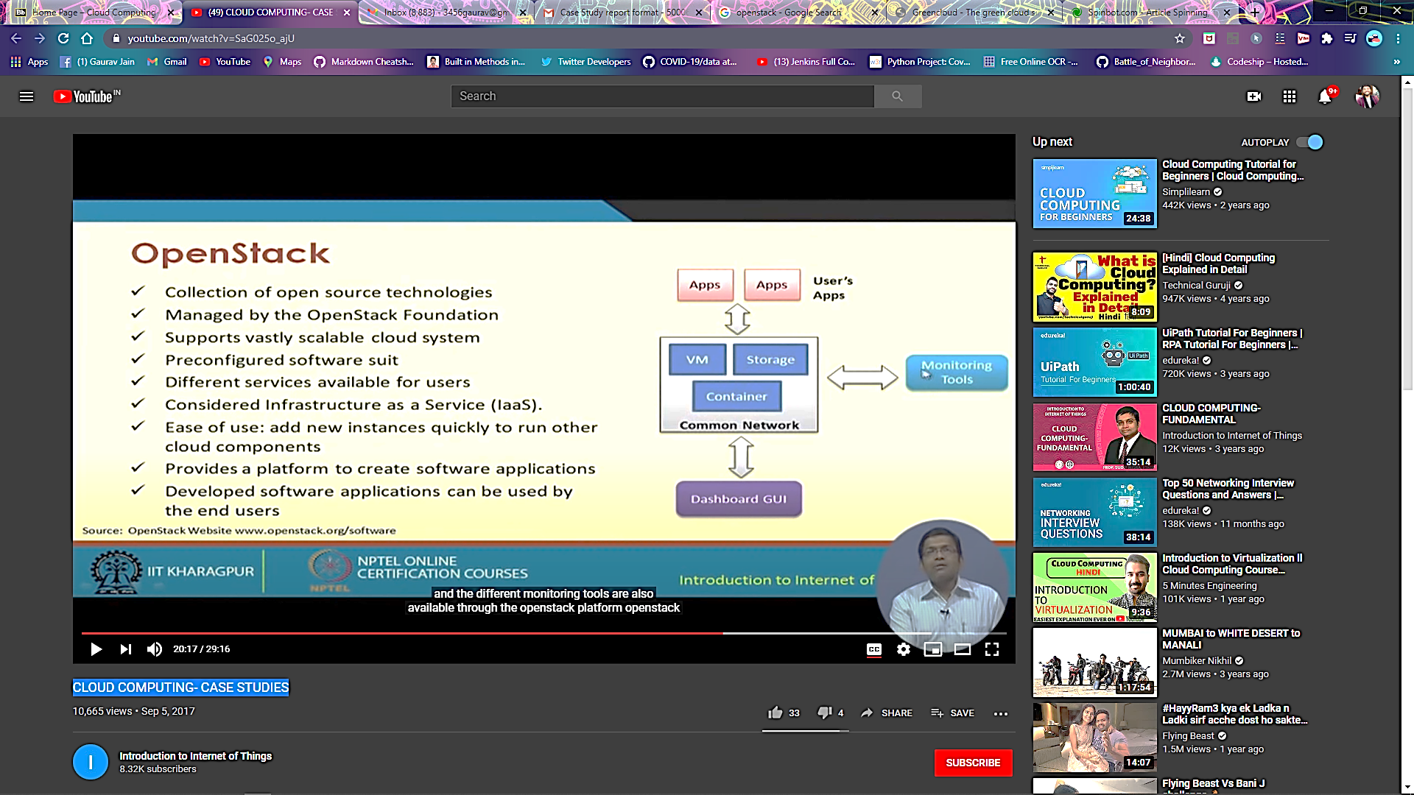

**Components of OpenStack**

* Compute
* Networking
* Block Storage
* DNS
* Key Manager

**Features of openStack:**

* Allows Users to Create and deploy virtual Machines
* Allows Set up Cloud Management environment
* Supports easy horizontal Scaling

1. **Microsoft Azure:**

* Supports Iaas and Paas
* Supports extensive set of Services to quickly create ,deploy and manage applications
* Many programming languages and frame works are Supported
* Available across Microsoft-managed datacenters

**Services:**

* Compute
* Mobile Services
* Data Management
* Messaging
* Media Services
* Content Delivery Network

**Azure as Paas**

* Platform is provided to clients to develop and deploy software
* Clients focus on Application deployment rather than worry about hardware and infrastructure
* Low cost
* Ease to move on to new tools

**Azure as Iaas**

* Offers Total Control of the OS and application Stack
* Features to access ,manage and monitor the data Centers
* Facility for loading of Custom Configurations

1. **Amazon Elastic Compute Cloud(EC2)**

* A Web Service for User’s to launch and Manage Server instances in Amazons data Center
* Provides Various API’S tools and Utilities
* Facilitate dynamic computation scaling in AWS Cloud
* Supports pay-per-bill

**Features of Amazon EC2**

* Supports all OS
* Storage

1. Temporary:Local ‘Instance Storage’
2. EBS
3. S3

* Automated Scaling
* Different availability zones in data centers increases fault-tolerance
* Firewall Rules/Security Groups
* Elastic I/P address
* Amazon CloudWatch
* Enhanced Security
* Virtual Private Clouds

**Reference**: https://www.youtube.com/watch?v=SaG025o_ajU